Group 6: PROgrammers
HomeNeedsService.com System Database Design
Group Captain: Yessica Rodriguez 0414909
Oscar Torres 463454
Daniela Tamayo 20336461
Ulvi Bajarani 20539914

- PROBLEM STATEMENT
With advances in technology, the usage of the internet has increased. People use the internet to shop, conduct research, get entertained, and more. No longer do ads in the newspaper work. However, it is not easy to find someone who offers more household or “handyman” services on the internet or for these people to find customers. Therefore, in this project, an application, HomeNeedsService.com, will be created to provide a platform for users to schedule providers for these services. In the application, the user will be able to search a service and enter all the necessary information to schedule the service. The information would include the location, time, and date. Once that is completed, providers of the service that have an account in this application and are available during the scheduled time will be notified. A provider will take up the accept the offer and the user will receive confirmation. This application will be connected to a database that will contain all necessary information.

- DATABASE DESIGN
The database created is a relational database consisting of 22 tables. An Entity-Relational (E-R) Model was created to map out the relationship between each entity or table in the database. The model is shown in Figure 1.
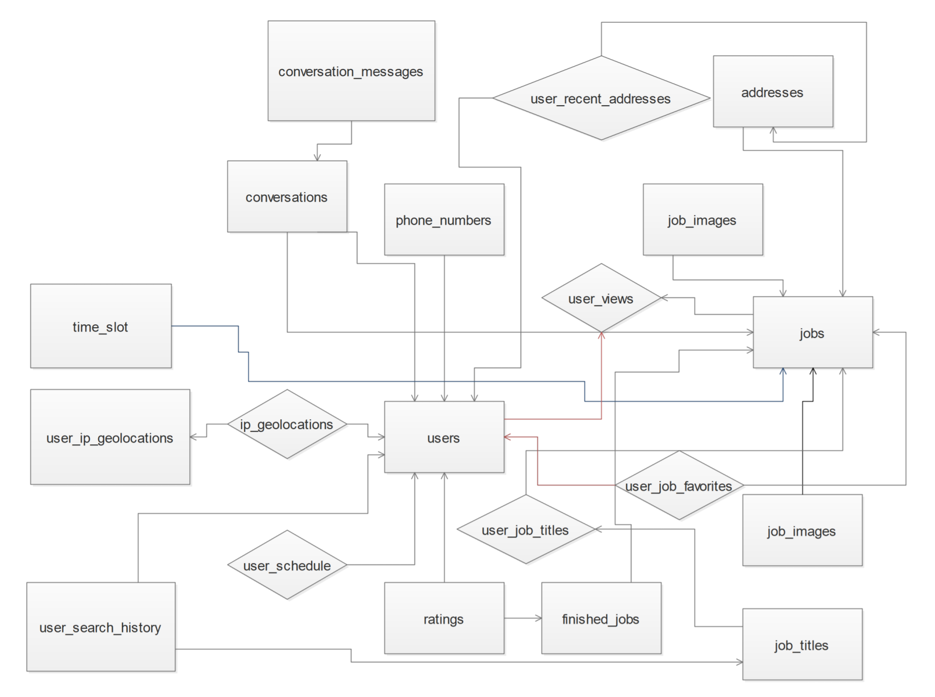
Figure 1: E-R Model
Using this model, the database was created. The schemas of those tables and their relations are shown in Figure 2.
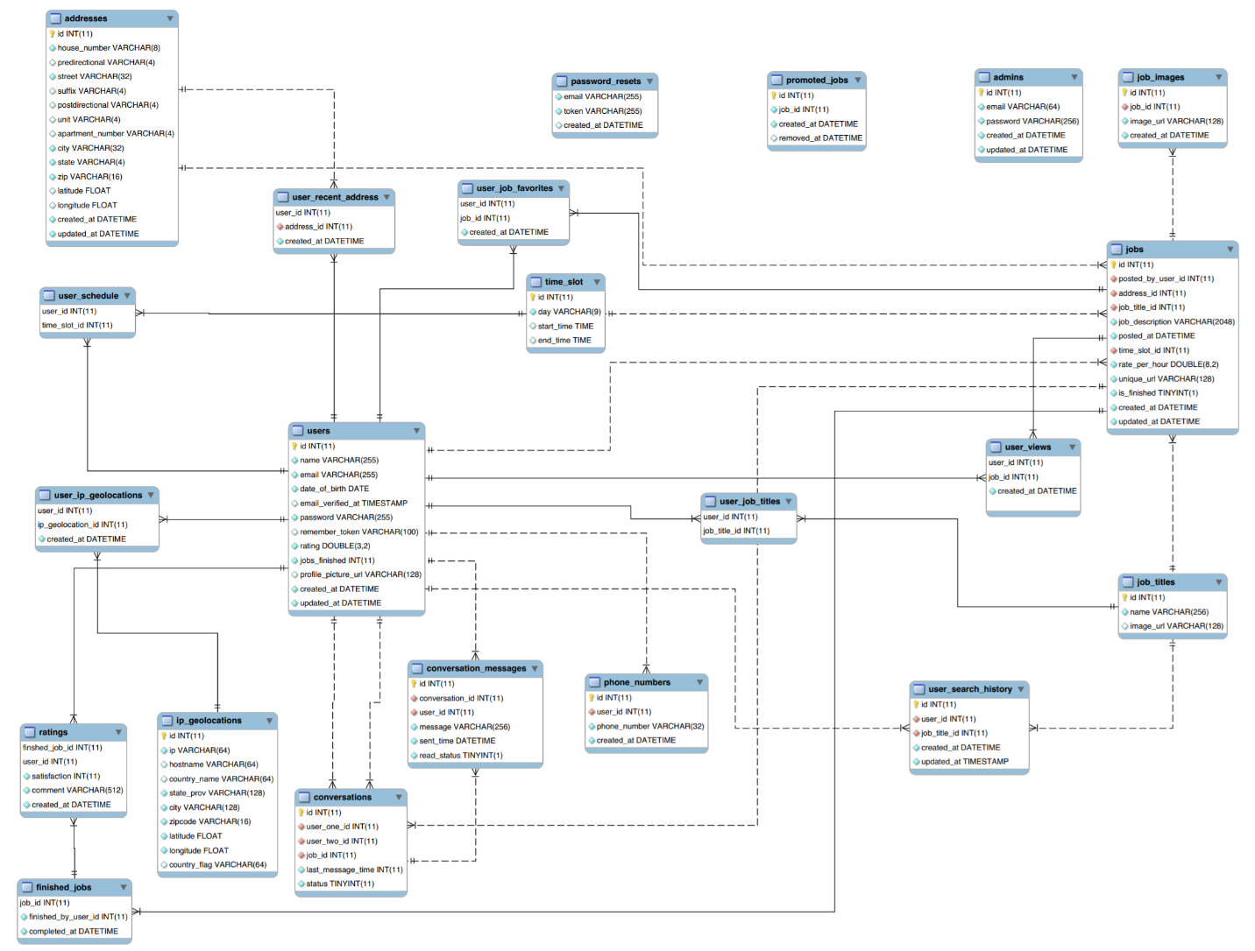
Figure 2: The Relational Diagram of The Database
The A brief description of each table is provided below:

addresses:
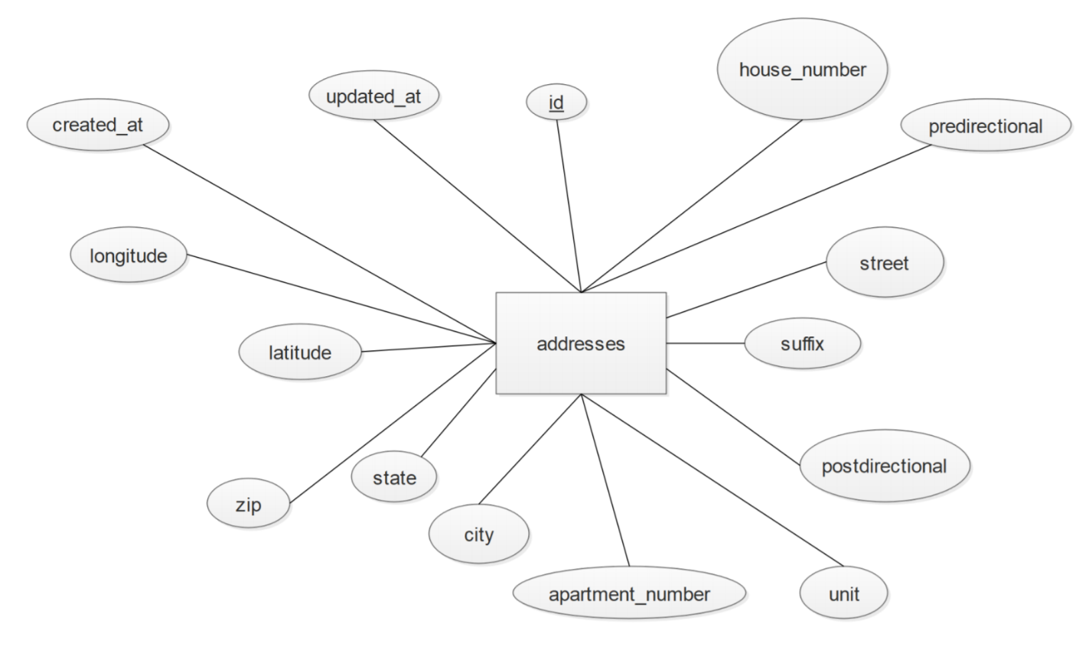
Figure 3: addresses Table Diagram
Description: The addresses table stores information of all addresses of each user and job. Each user can have many addresses. And each address can have many jobs. The “addresses” table is involved in a one-to-many relationship with the jobs table. This means that one address may have many “jobs.”
id: This is the primary key for the addresses table. Type: Integer(11)
house_number: This is the house number for the particular address. Type: Text(8)
predirectional: This is the predirectional, if there is one, for the particular address. Type: Text(4)
street: This is the street name for the particular address. Type: Text(32)
suffix: This is the suffix, if there is one, for the particular address. Type: Text(4)
postdirectional: This is the postdirectional, if there is one, for the particular address. Type: Text(4)
unit: This is the unit, if there is one, for the particular address. Type: Text(4)
apartment_number: This is the apartment number, if there is one, for the particular address. Type: Text(4)
city: This is the city name for the particular address. Type: Text(32)
state: This is the state name for the particular address. Type: Text(4)
zip: This is the zip code for the particular address. Type: Text(16)
latitude: This is the latitude value for the particular address. Type: Float
longitude: This is the longitude value for the particular address. Type: Float
created_at: This is the date and time the particular address was created. Type: Datetime
updated_at: This is the date and time the particular address was updated. Type: Datetime

user_schedule:
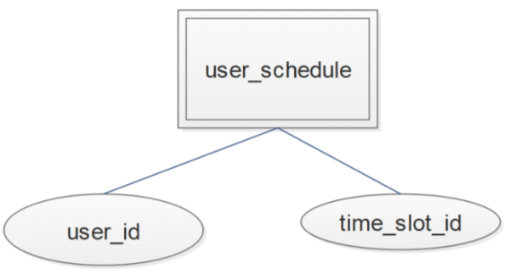
Figure 4: user_schedule Table Diagram
Description: The user_schedule table stores information of all the time slots that a user is available. Each user can have many time slots. And each time slot can be applicable for many users. This means that many users can be available at the same time slots.
user_id: This is the user id of the user that is available at the particular time slot. Type: Integer(11)
time_slot_id: This is the time slot id of the time slot that the particular user is available for. Type: Integer(11)

user_ip_geolocations:
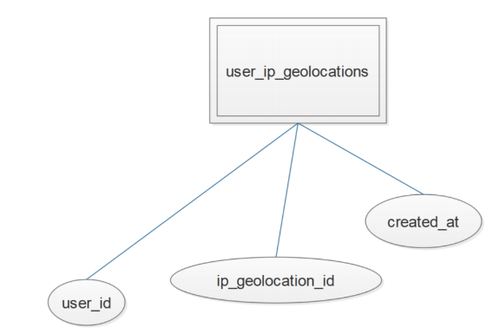
Figure 5: user_ip_geolocations Table Diagram
Description: The user_ip_geolocations table stores the information of the IP each user gets when accessing the website. Each user can have many accessing coordinates. Each time a particular user access the website, the website is provided with the new pair of coordinates, latitude and longitude of that IP address, as well with the date and time this happened.
user_id: This is the user id of the user that is accessing the website. Type: Integer(11)
ip_geolocation_id: This is the id of the ip_geolocation provided when accessing the website. Type: Integer(11)
created_at: This is the date and time the website was visited by that particular user. Type: Datetime

ip_geolocations:
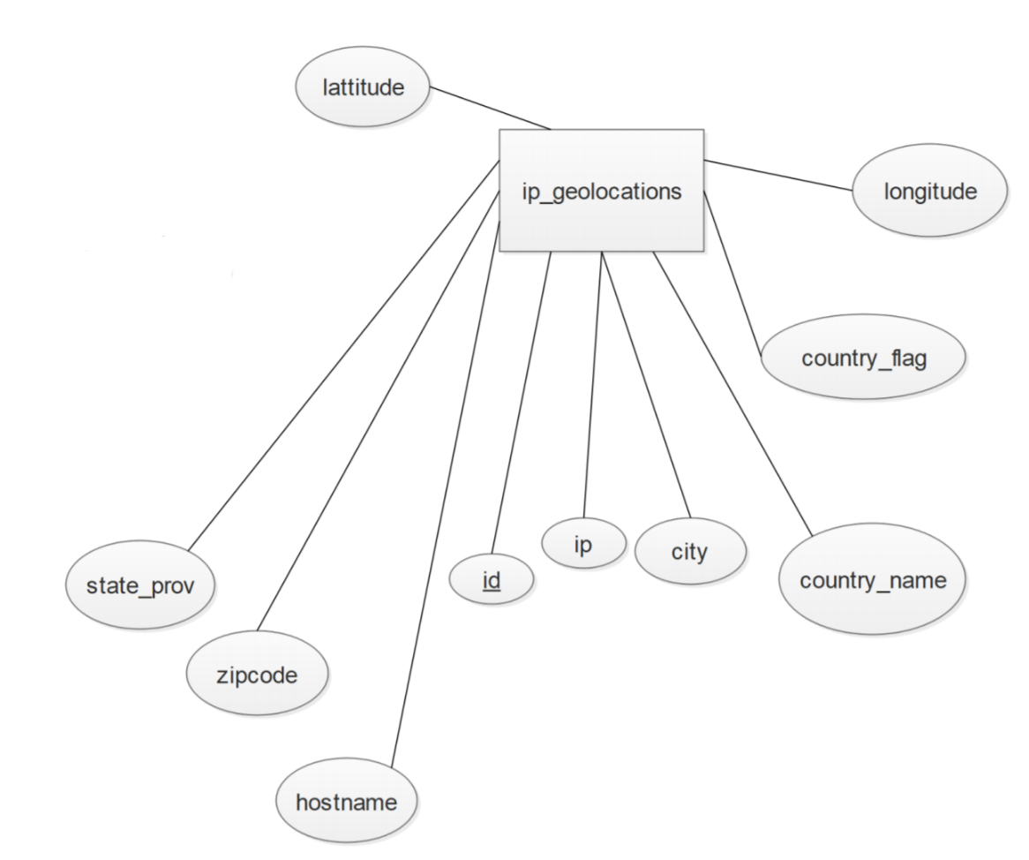
Figure 6: ip_geolocations Table Diagram
Description: The ip_geolocations table stores the information that helps to determine the users’ location. Each user can log in from many locations. It helps regulate the distance requirement set by each user as well. Each time the users access the website, the website is provided with the pair of coordinates, latitude and longitude of that IP address.
id: This is the primary key for the ip_geolocations table. Type: Integer(11)
ip: This is the IP address provided when the user accesses the website. Type: Text(64)
hostname: This is the hostname provided when the user accessees the website. Type: Text(64)
country_name: This is the country name of the IP address provided. Type: Text(64)
state_prov: This is the state name of the IP address provided. Type: Text(128)
city: This is the city name of the IP address provided. Type: Text(128)
zipcode: This is the zip code of the IP address provided. Type: Text(16)
latitude: This is the coordinate value of the origin of the IP address. Type: Float
longitude: This is the coordinate value of the origin of the IP address. Type: Float
country_flag: Type: Text(64)

user_recent_address:
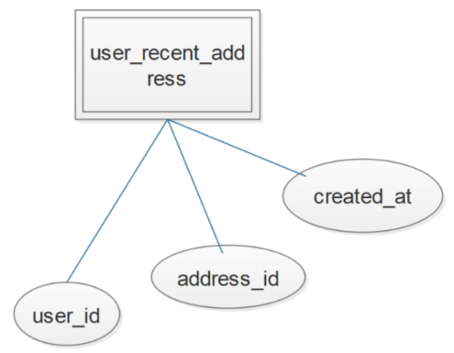
Figure 7: user_recent_address Table Diagram
Description: The user_recent_address table stores information of all the addresses used recently by the users. Each user could have recently used many addresses. And each address could have been recently used many times.
user_id: This is the user id of the user that has recently used the particular address. Type: Integer(11)
address_id: This is the address id of the address recently used by the particular user. Type: Integer(11)
created_at: This is the date and time that the particular address was used by the particular user. Type: Datetime

users:
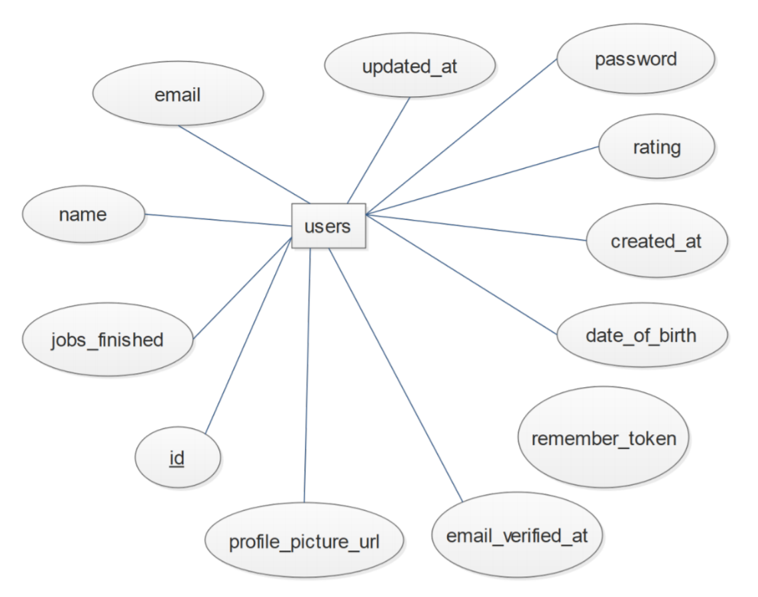
Figure 8: users Table Diagram
Description: The users table stores information of all the users. The “users” table is involved in a one-to-many relationship with many different tables – user_schedule, user_ip_geolocations,, ratings, conversations, conversation_messages, phone_numbers, user_job_titles, user_views, jobs, user_job_favorites, and user_recent_address.
id: This is the primary key for the users table. Type: Integer(11)
name: This is the name of the particular user. Type: Text(255)
email: This is the email address of the particular user. Type: Text(255)
date_of_brith: This is the date of birth of the particular user. Type: Date
email_verified_at:This is the time that the email address of the particular user was verified. Type: Timestamp
password: This is the password of the particular user. Type: Text(255)
remember_token: This is the token generated to authenticate user for resets of password. Type: Text(100)
rating: This is the rating score of the user. Type: Double(3,2)
jobs_finished: This is the number of jobs finished by the particular user. Type: Integer(11)
profile_picture_url: This is the profile picture url of the particular user. Type: Text(128)
created_at: This is the date and time the particular user account was created. Type: Datetime
updated_at: This is the date and time the particular user account was updated. Type: Datetime

conversations:
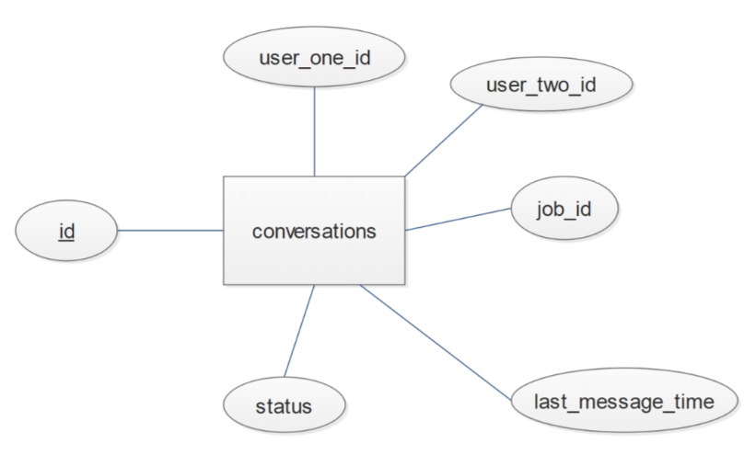
Figure 9: conversations Table Diagram
Description: The conversations table stores information about the users communication with a customer or other user. Each user can have several conversations with many different users. Each job can have many conversations between users. And each conversation will have many messages. The “conversations” table is involved in a one-to-many relationships with the conversation_messages table. This means that each conversation can have many messages.
id: This is the primary key for the conversations table. Type: Integer(11)
user_one_id: This is the user id one participant of the particular conversation. Type: Integer(11)
user_two_id: This is the user id the other participant of the particular conversation. Type: Integer(11)
job_id: This is the job id of the job being discussed in the particular conversation. Type: Integer(11)
last_message_time: This is the time that the last message of the particular conversation was sent. Type: Integer(11)
status: This is the status of the particular conversation. Type: Integer(11)

conversation_messages:
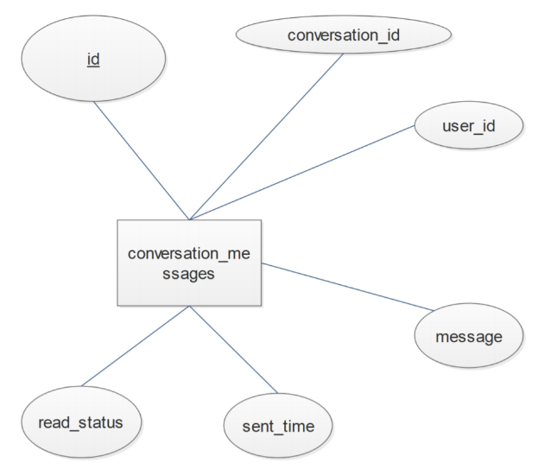
Figure 10: conversation_messages Table Diagram
Description: The conversation_messages table stores information about the messages of conversations between users. Each conversation can have many messages. And each user have have many messages.
id: This is the primary key for the conversation_messages table. Type: Integer(11)
conversation_id: This is the conversation id that the particular message belongs to. Type: Integer(11)
user_id: This is the user id that the particular message was sent to. Type: Integer(11)
message: This is the actual message sent. Type: Text(256)
sent_time: This is the date and time that the particular message was sent. Type: Datetime
read_status: This integer value represents whether the user has read the particular message. If the value is 0, then the user has not read the message. If the value is 1, the user has read the message. Type: Integer(1)

ratings:
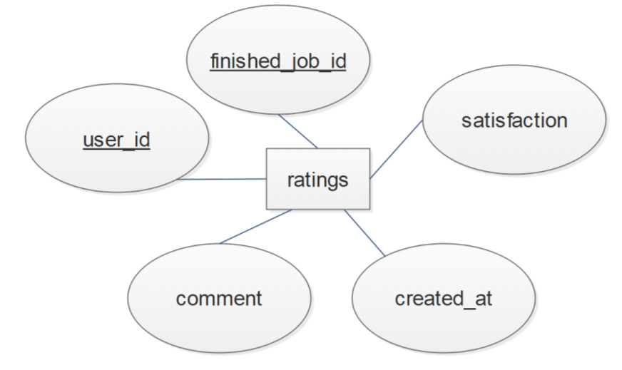
Figure 11: ratings Table Diagram
Description: The ratings table stores information about the user’s satisfaction with finished jobs. Each user can rate and comment many jobs.
finished_job_id: This is the job id of the particular finished job being rated and commented. Type: Integer(11)
user_id: This is the user id of the user rating and commenting the particular finished job. Type: Integer(11)
satisfaction: This is the rating score given by the user to the particular finished job. Type: Integer(11)
comment: This is the comment given by the user to the particular finished job. Type: Text(512)
created_at: This is the date and time the rating and comment for the particular finished job were made. Type: Datetime

user_job_favorites:
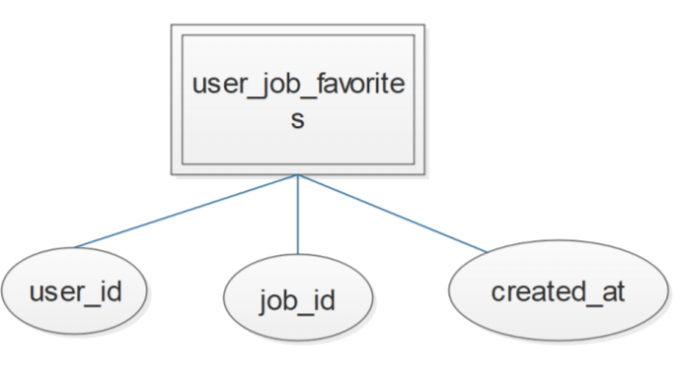
Figure 12: user_job_favorites Table Diagram
Description: The user_job_favorites table stores information about all the favorite jobs of the users. Each user can have many favorite jobs. And each job can be the favorite of several users.
user_id: This is the user id of the user that favorites the particular job. Type: Integer(11)
job_id: This is the job id of the favorite job of the particular user. Type: Integer(11)
created_at: This is the date and time that the particular user favorited the particular job. Type: Datetime

time_slot:
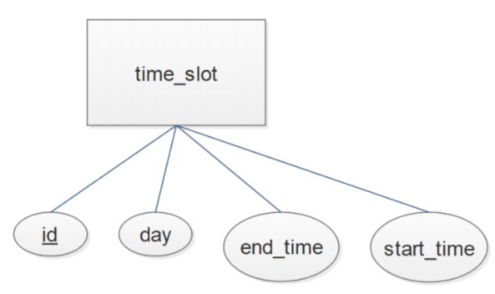
Figure 13: addresses Table Diagram
Description: The time_slot table stores information about all the possible or available time slots a user can be available. Each user can be available several times. And each time slot can be apply for several users. The “time_slot” table has a one-to-many relationship with user_schedule table. This means that many users can be available at the time slots.
id: This is the primary key for the time_slot table. Type: Integer(11)
day: This is the name of the day of the week for the particular time slot. Type: Text(9)
start_time: This is the start time of the particular time slot. Type: Time
end_time: This is the end time of the particular time slot. Type: Time

password_resets:
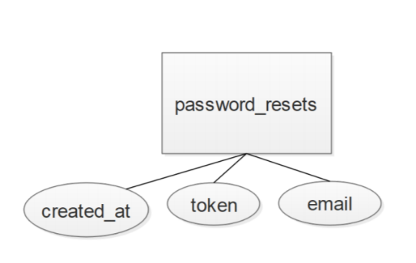
Figure 14: addresses Table Diagram
Description: The password_resets table stores information necessary for users to be able to reset their passwords.
email: This is the email address of the user that needs to change his password. Type: Text(255)
token: This is the token generated to authenticate the user. Type: Text(255)
created_at: This is the date and time that the token was created. Type: Datetime

phone_numbers:
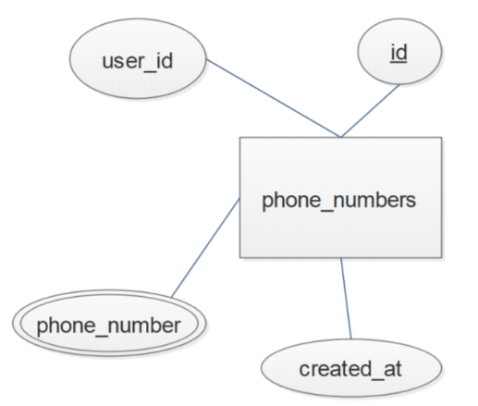
Figure 15: phone_number Table Diagram
Description: The phone_numbers table stores information about users’ phone numbers. Each user can have several phone numbers.
id: This is the primary key for the phone_numbers table. Type: Integer(11)
user_id: This is the user id that the particular phone number belongs to. Type: Integer(11)
phone_number: This is the actual phone number. Type: Text(32)
created_at: This is the date and time that the particular number was created. Type: Datetime

user_search_history:
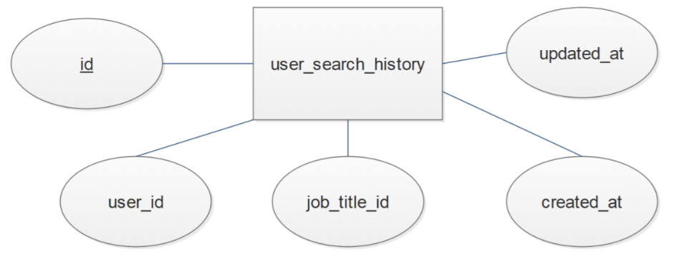
Figure 16: user_search_history Table Diagram
Description: The user_search_history table stores information about all the users’ searches. Each user can do several searches. The id of the job searched gets stored as well as the date and time of this specific search.
id: This is the primary key for the user_search_history table. Type: Integer(11)
user_id: This is the user id of the user doing the particular search. Type: Integer(11)
job_title_id: This is the id of the job title of the particular search. Type: Integer(11)
created_at: This is the date and time of when the particular search was made. Type: Datetime
updated_at: This is the date and time of when the particular search was updated. Type: Timestamp

jobs:
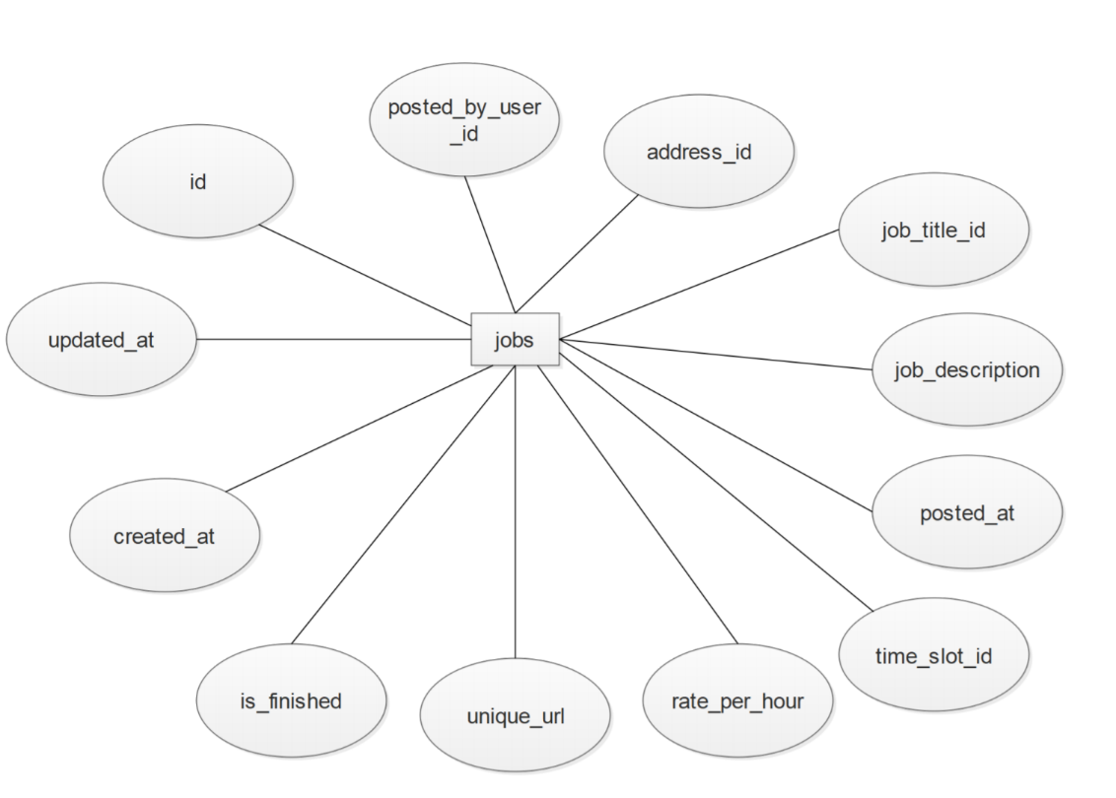
Figure 17: jobs Table Diagram
Description: The jobs table stores information of each job posted by a user. Each user can post many jobs. Each job title, address, and time slot can be applicable for many jobs. And each job can have many images and be favorited by many users.
id: This is the primary key for the jobs table. Type: Integer(11)
posted_by_user_id: This is the user id of the user that posted the particular job. Type: Integer(11)
address_id: This is the address id of the address for the particular job. Type: Integer(11)
job_title_id: This is the job title id for the particular job. Type: Integer(11)
job_description: This is a description of the particular job. Type: Text(2048)
posted_at: This is the date and time the particular job was posted. Type: Datetime
time_slot_id: This is the time slot id that the particular job Type: Integer(11)
rate_per_hour: This is the salary per hour for the completion of the particular job. Type: Double
unique_url: Type: Text(128)
is_finished: This integer value represents whether the particular job has been completed or not. If the value is 0, the job has not been finished. If the value is 1, the job has finished. Type: Integer(1)
created_at: This is the date and time that the particular job was created. Type: Datetime
updated_at: This is the date and time that the particular job was updated. Type: Datetime

job_images:
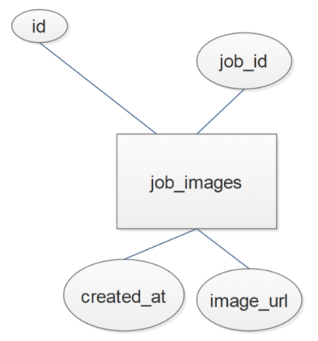
Figure 18: addresses Table Diagram
Description: The job_images table stores information icons or images that describe the jobs. Each job can have many images.
id: This is the primary key for the job_images table. Type: Integer(11)
job_id: This is the job id of the image job of the particular job. Type: Integer(11)
image_url: This is the url of the image of the particular job. Type: Text(128)
created_at: This is the date and time of when the image was created. Type: Datetime

job_titles:
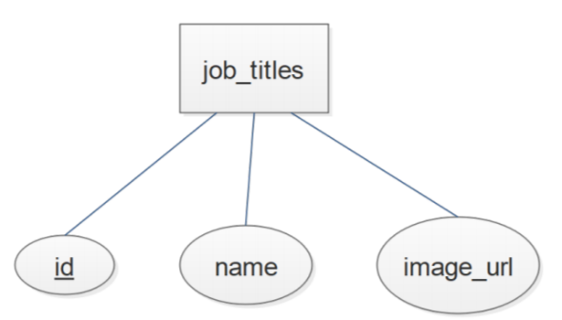
Figure 19: addresses Table Diagram
Description: The job_titles table stores information of the titles for each job. Each job can have many names or images.
id: This is the primary key for the job_titles table. Type: Integer(11)
name: This is the name of the particular job. Type: Text (256)
image_url: This is the url of the image of the particular job. Type: Text(128)

promoted_jobs:
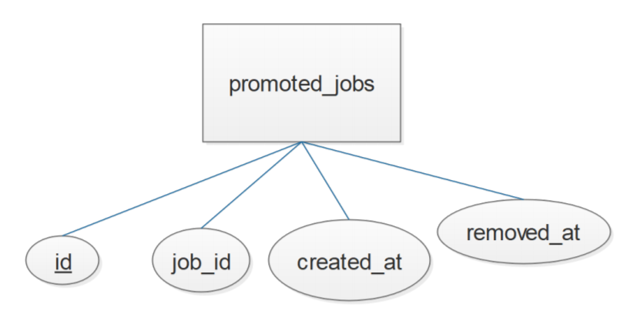
Figure 20: addresses Table Diagram
Description: The promoted_jobs table stores information of the job being promoted. Each user can promote or remove many jobs.
id: This is the primary key for the promoted_jobs table. Type: Integer(11)
job_id: This is the id of the job being promoted. Type:Integer(11)
created_at: This is the date and time of when the promoted job was created. Type: Datetime
removed_at: This is the date and time of when the promoted job might have been removed. Type: Datetime

user_job_titles:
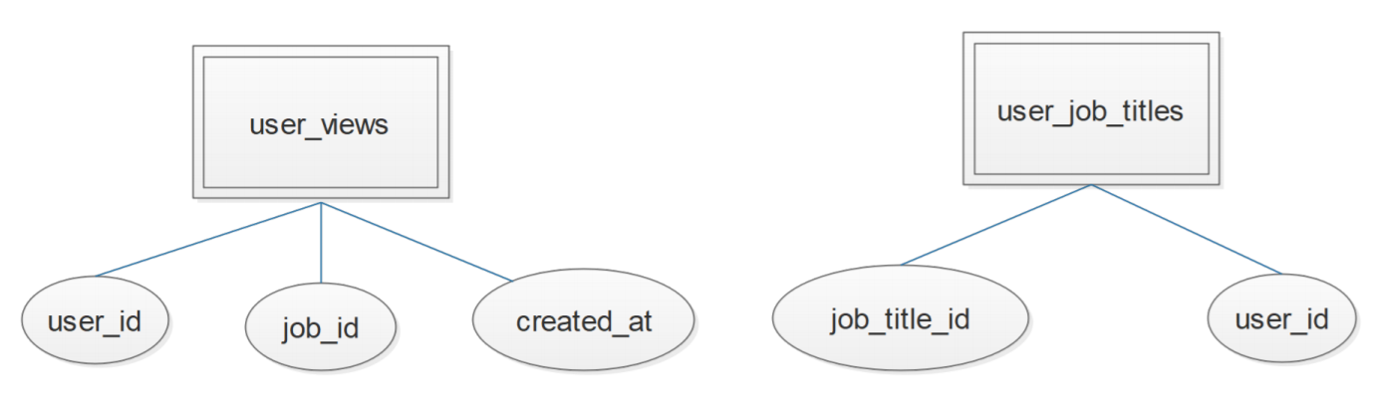
Figure 21: addresses Table Diagram
Description: The user_job_titles table stores information of the user and its respective jobs. Each user id can have multiple jobs.
user_id: This is the user id that the particular job title belongs to. Type: Integer(11)
job_title_id: This is the job title id of the users’ particular job. Type: Integer(11)

user_views:
Figure 22: addresses Table Diagram
Description: The user_views table stores information of the views each user has had respect to the job, as well as the date and time this view occurred.
user_id: This is the user id that the particular view belongs to. Type: Integer(11)
job_id: This is the job id that the particular view belongs to Type: Integer(11)
created_at: This is the date and time of when the view occurred. Type: Datetime

admins:
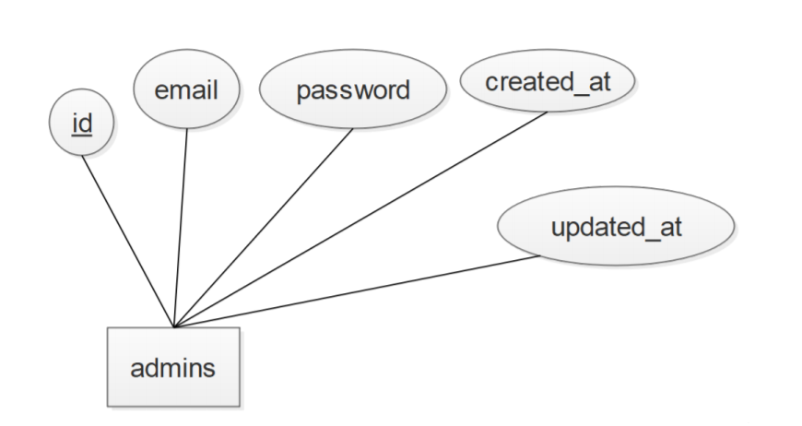
Figure 23: addresses Table Diagram
Description: The admins table stores information of the application’s administrative user accounts.
id: This is the primary key of the admins table. Type: Integer(11)
email: This is the email address of the particular administrative user account. Type: Text(64)
password: This is the password of the particular administrative user account. Type: Text(256)
created_at: This is the date and time the particular administrative user account was created. Type: Datetime
updated_at: This is the date and time the particular administrative user account was updated. Type: Datetime

finished jobs:
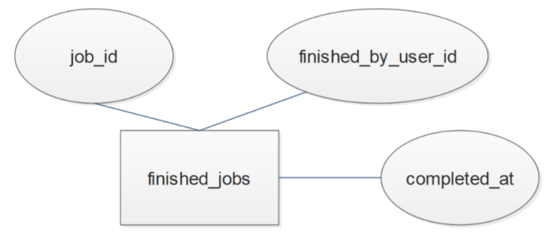
Figure 24: addresses Table Diagram
Description: The finished_jobs table stores information of each finished job. Each job can be finished. And each finished job can be rated.
job_id: This is the job id of the particular finished job. Type: Integer(11)
finished_by_used_id: This is the user id of the user that finished the particular finished job. Type: Integer(11)
completed_at: This is the date and time the particular finished job was finished. Type: Datetime

Group 6: PROgrammers
HomeNeedsService.com System Software Design
Group Captain: Yessica Rodriguez 0414909
Oscar Torres 463454
Daniela Tamayo 20336461
Ulvi Bajarani 20539914

Table of Contents
1. INTRODUCTION 22
1.1. Purpose 22
1.2. Scope 22
1.3. Definitions and Acronyms 22
2. REFERENCES 22
3. DECOMPOSITION DESCRIPTION 22
3.1. DataStore Module Description 22
3.2. DataProcessing Module Description 24
3.3. UserInterface Module Description 24
4. DEPENDENCY DESCRIPTION 24
4.1. Inter-module Dependencies 24
4.1.1. Database 24
4.1.2. DataProcessing Module 25
4.1.3. UserInterface Module 25
4.2. Inter-process Dependencies 25
5. INTERFACE DESCRIPTION 25
5.1. Module Interface 25
5.1.1. DataStore Module Interface Description 25
5.1.2. DataProcessing Module Interface Description 25
5.1.3. Userinterface Module Interface Description 25
6. DETAILED DESIGN 25
6.1. Module Detailed Design 25
6.1.1. Database Detailed Design 25
6.1.2. Application Program Detailed Design 25
6.1.3. UserInterface Module Detailed Design 26
6.2. Data Detailed Design 31
6.2.1. Variable Definition Description 31
6.2.2. Variable Type Description 31
6.3. Process Integration 31

INTRODUCTION

Purpose
In this document, we describe the HomeNeedsService.com system software design. In Section 3, 4 and 5, we present the architecture of the system. In Section 6, we give the final details that guide the implementation of the system.

Scope
This design is for both the prototype and the operation versions of HomeNeedsService.com system software.

Definitions and Acronyms
HDBD HomeNeedsService.com Database Design
HNS HomeNeedsService.com
AWS Amazon Web Services

REFERENCES
Group 6: PROgrammers - HomeNeedsService.com System Database Design

DECOMPOSITION DESCRIPTION
At the high level, the HNS system consists of three modules, DataStore, DataProcessing, and UserInterface. Figure 3.1 gives structure chart of the system framework.
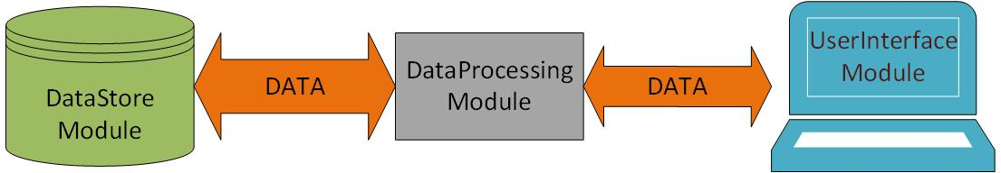
Figure 3.1. Structure Chart of DB_PROJECT Software Framework

DataStore Module Description
DataStore Module stores data that can be accessed and modified by DataProcessing Module to satisfy user requirements of data storing, updating, and querying. It is the database of the system, which consists of a collection of tables that may be relational to each other as described in HDBD. Figure 3.2 presents the structure of DataStore Module.
Refer to HDBD for detailed database able description.
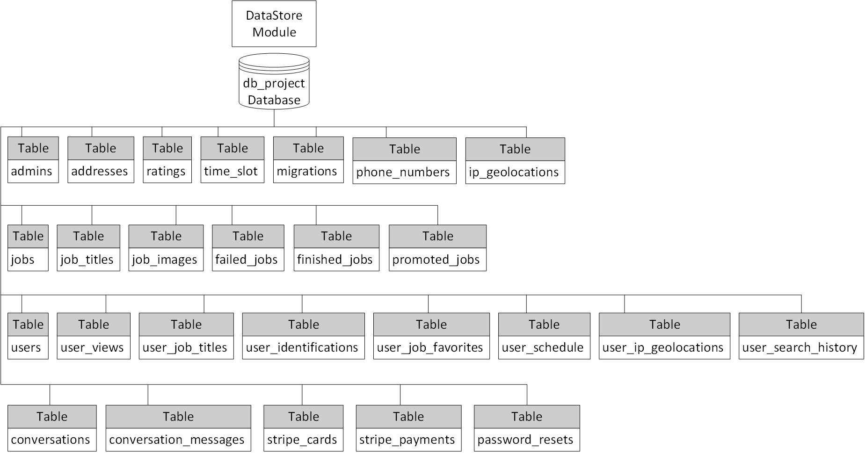
Figure 3.2. The Structure of DataStore Module

DataProcessing Module Description
DataProcessing Module performs all the operations that the HNS system provides to the users. It controls the data processing procedure of the system and generates the dynamic data of the web pages to the users. This module consists of 5 function sets, which are Computation Function Set, Database Connection Function Set, Data Retrieval Function Set, Data Update Function Set, and User Authentication Function Set.
Computational Function Set includes all the sub-functions that perform validation, formula calculation, and other computation required by users or application programs. Database Connection Function Set consists of the functions that connect to the database server. Data Retrieval Function Set consists of all the functions that retrieve specific data or information from the database. Data Update Function Set consists of all the functions that add new data to the database or modify original data of the database. User Authentication Function Set consists of all the functions of user authorization and session management.

Figure 3.3 Function Call Relationship Diagram Among Function Sets
Figure 3.3 gives the function call relationship among function sets of the module. An arrow shows relationship from a callee to a caller. A caller can call a function in the function set that has an arrow line pointing to the caller. The hierarchical decomposition of DataProcessing Module is illustrated in Figure 3.4.

Figure 3.4 Hierarchical Decomposition Diagram of DataProcessing Module

UserInterface Module Description
UserInterface Module is used to maintain consistent appearances for all aspects of the system. It provides interfaces for users to interact with the system.

DEPENDENCY DESCRIPTION

Inter-module Dependencies

Database
The database resides in a server machine with the database named db_project.
The database can be accessed only by DataProcessing Module with authorized users through PDO_MYSQL. There are two data resources of this module, Use Input Data and System Generated Data. User Input Data are generated by authorized users, and System Generated Data are created authomatically by software functions.
Table 4.1 lists the resources on which DataStore Module depends. The attributes of the hardware are selected in order to satisfy demands of performance.
Hardware | Software
 | Amazon Web Services (AWS)
Table 4.1 SQL/Web Server Resources
Refer to ADBD v1.1 for dependencies between table

DataProcessing Module
DaraProcessing Module resides and is executed in the same Web Server machine. This module accesses DataStore Module through PDO_MYSQL and exachanges data with UserInterface Module through AWS services. DataProcessing Module functions process and retrieval data from/to both DataStore Module and UserInterface Module.

UserInterface Module
The UserInterface Module resides on the same Web Server machine as DataProcessing Module and Database sharing the same resources. It generates HTML web pages for the users to interact with the system. The web pages can execute on any client PC that connects to the Web Server through Internet and can be accessed by any client PC to Web Server via a web browser such as Internet Explorer and Google Chrome.

Inter-process Dependencies
The functions of DataProcessing Module and static web pages of UserInterface Module are integrated into PHP files that are requested by the users from client machines and execute as process entities in the form o PHP code. For the relationship among these PHP entities, see Figure 6.3 for state transition diagram of all the PHP files.

INTERFACE DESCRIPTION

Module Interface

DataStore Module Interface Description
PDO_MYSQL Driver for mySQL is used to provide access to the DataStore Module. SQL language is used to carry out the operations of database accesses.

DataProcessing Module Interface Description
DataProcessing Module accesses database through PDO. SQL language is used to carry out the operations of database accesses. The DataProcessing Module inputs PHP code and http requests.

Userinterface Module Interface Description
Web Browser is used as in interface by UserInterface Module to interact with users. All information required by the users is presented to them via web browser. Users’ requests and their input data are sent to DataProcessing Module via HTTP requests.

DETAILED DESIGN

Module Detailed Design

Database Detailed Design
Refer to HDBD for the detailed description of the HNS database design.

Application Program Detailed Design

UserInterface Module Detailed Design
All the Blade PHP page codes reside in the folder named \resources\views. All the pages will have a link to the Welcome page. In addition, if a user is not signed in, all the pages will have a link to the Register and Login pages. However, if a user is signed in, all the pages will have a link to the Profile page instead of Register and Login pages.

Welcome Page
Name: welcome.blade.php
Input Variable:
None
Output Variable:
None
Link to:
 | Page Name
1 | Login
2 | Register
3 | Job

Login Page
Name: login.blade.php
Input Variable:
None
Output Variable:
 | Description | Type
1 | Textfield: User Email Address | String
2 | Textfield: Password | String
3 | Button: Login | Button
4 | Button: Remember Me | Button
5 | Button: Forgot Your Password? | Button
Link to:
 | Page Name
1 | Profile
2 | Reset

Register Page
Name: register.blade.php
Input Variable:
None
Output Variable:
 | Description | Type
1 | Textfield: Name | String
2 | Textfield: User Email Address | String
3 | Textfield: Password | String
4 | Textfield: Confirm Password | String
5 | Button: Register | Button
Link to:
 | Page Name
1 | Profile

Job Page
Name: job.blade.php
Input Variable:
 | Description | Type
1 | Job Title Name | String
2 | Job Description | String
3 | Job Pay Rate | String
4 | Job Location | String
Output Variable:
 | Description | Type
1 | Button: Chat | Button
2 | Button: View phone number | Button
3 | Button: Rating | Button
4 | Button: Related | Button
5 | Button: View | Button
Link to:
 | Page Name
1 | Chat
2 | Job

Profile Page
Name: profile.blade.php
Input Variable:
 | Description | Type
1 | User ID | Integer
Output Variable:
 | Description | Type
1 | Button: Name | Button
2 | Button: User Email Address | Button
3 | Button: Password | Button
4 | Button: Confirm Password | Button
5 | Button: Register | Button
Link to:
 | Page Name
1 | Profile Edit
2 | Favorites
3 | User Jobs
4 | Schedule

Reset Page
Name: reset.blade.php
Input Variable:
None
Output Variable:
 | Description | Type
1 | Textfield: User Email Address | String
2 | Button: Send Password Reset Link | Button
Link to:
 | Page Name
1 | Confirm

Chat Page
Name: chat.blade.php
Input Variable:
 | Description | Type
1 | Chat Recipient User ID | Integer
2 | Chat Sender User ID | Integer
Output Variable:
 | Description | Type
1 | Textfield: Message | String
2 | Button: Send | Button
Link to:
None other than Welcome and Register & Login or Profile

Confirm Page
Name: confirm.blade.php
Input:
 | Description | Type
1 | User Email Address | String
Output:
None
Link to:
None other than Welcome and Register & Login or Profile

New Password Page
Name: newPassword.blade.php
Input:
 | Description | Type
1 | User ID | Integer
Output:
 | Description | Type
1 | Textfield: New Password | String
2 | Textfield: New Password Confirmation | String
Link to:
None other than Welcome and Register & Login or Profile

Favorites Page
Name: favorites.blade.php
Input:
 | Description | Type
1 | User ID | Integer
Output:
 | Description | Type
1 | Button: Edit | Button
2 | Button: Next | Button
Link to:
 | Page Name
1 | Favorites Edit
2 | Profile
3 | User Jobs
4 | Schedule

User Jobs Page
Name: userJobs.php
Input:
 | Description | Type
1 | User ID | Integer
Output:
 | Description | Type
1 | Button: Edit | Button
2 | Button: Next | Button
Link to:
 | Page Name
1 | User Jobs Edit
2 | Favorites
3 | Profile
4 | Schedule

Schedule Page
Name: schedule.blade.php
Input:
 | Description | Type
1 | User ID | Integer
Output:
 | Description | Type
1 | Button: Edit | Button
Link to:
 | Page Name
1 | Schedule Edit
2 | Favorites
3 | User Jobs
4 | Profile

Profile Edit
Name: profileEdit.blade.php
Input:
 | Description | Type
1 | User ID | Integer
Output:
 | Description | Type
1 | Textfield: Name | String
2 | Textfield: Email | String
3 | Textfield: Date of Birth | Date
4 | Textfield: Phone Numbers | Integers
5 | Textfield: Addresses | String
6 | Button: Save | Button
7 | Button: Cancel | Button
Link to:
 | Page Name
1 | Profile

Favorites Edit
Name: favoritesEdit.blade.php
Input:
 | Description | Type
1 | User ID | Integer
Output:
 | Description | Type
1 | Button: Delete | Button
2 | Button: Save | Button
3 | Button: Cancel | Button
Link to:
 | Page Name
1 | Favorites

User Jobs Edit
Name: userjobsEdit.blade.php
Input:
 | Description | Type
1 | User ID | Integer
Output:
 | Description | Type
1 | Button: Add | Button
2 | Button: Delete | Button
3 | Button: Save | Button
4 | Button: Cancel | Button
Link to:
 | Page Name
1 | User Jobs

Schedule Edit
Name: scheduleEdit.blade.php
Input:
 | Description | Type
1 | User ID | Integer
Output:
 | Description | Type
1 | Button: Add | Button
2 | Button: Delete | Button
3 | Button: Save | Button
4 | Button: Cancel | Button
Link to:
 | Page Name
1 | Schedule

Data Detailed Design

Variable Definition Description
The variables are divided into 3 categories: constant variables, session-wide variables and local variables.

Constant Variable
This program does not have any constant variables.

Session-wide Variable
Table 6.2.1.2 lists some of the session-wide variables that are used by system programs.
# | Variable | Type | Description
1 | userName | String | User Login Name
2 | userID | Integer | User Login identification
3 | userEmail | String | User’ Login Email
Table 6.2.1.2 Session-wide Variables

Local Variable
Most local variable are items that make up the page. For instance, the variable job title, which is a string, would influence the page based on the job selected by the user and be displayed accordingly. This example describes most other local variables.

Variable Type Description
PHP uses a variety of different types of variables, which are the commonly seen variables in coding languages. The data types include string, integer, float, Boolean, and more. Data types do need to be explicitly stated, but one should not attempt to save another data type in a variable that was used for a different data type.

Process Integration
The function of DataProcessing Module and web pages of UserInterface Module are integrated into PHP code program to satisfy the requirement for each Active Server Page.
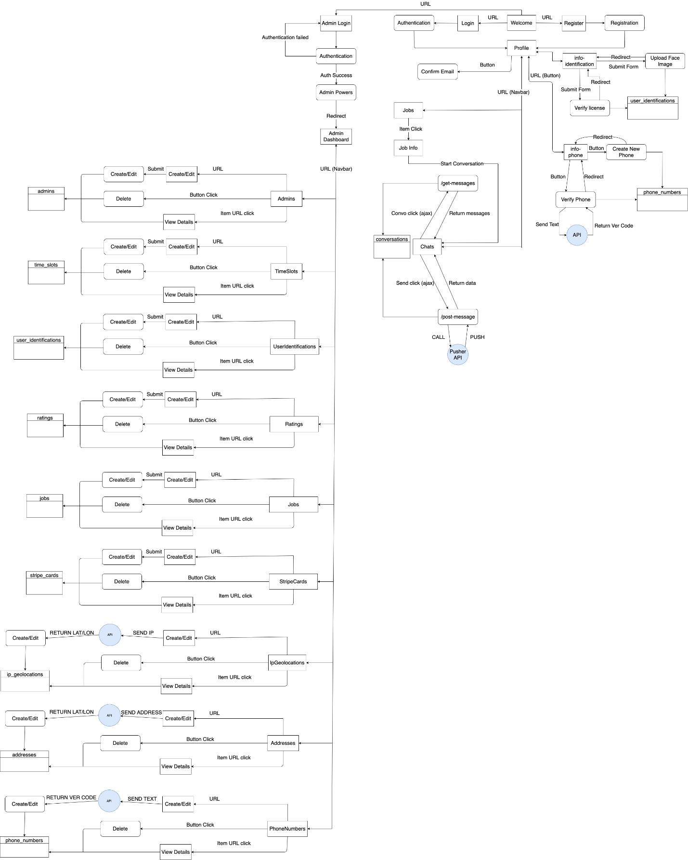
Figure 6.3 State Transition Diagram

